SIGNALS

TASK 1:

LOOP

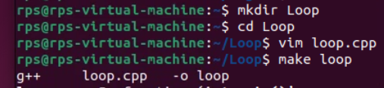

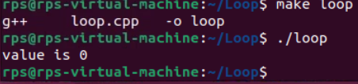

TASK 2:

SIGNAL

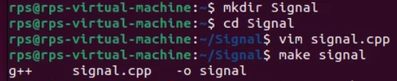

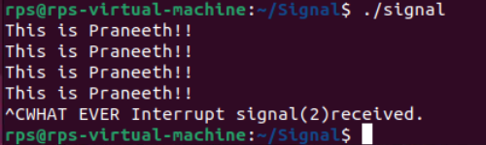

TASK 3:

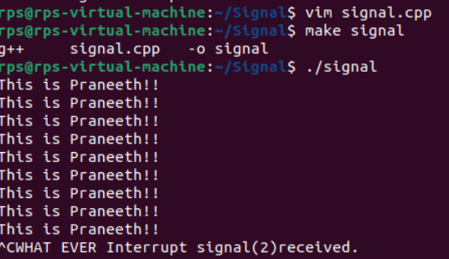

TASK 4:

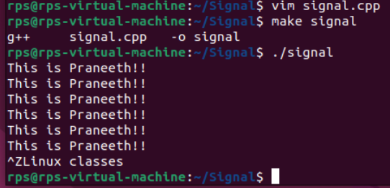

TASK 5:

SIGNAL ACTION

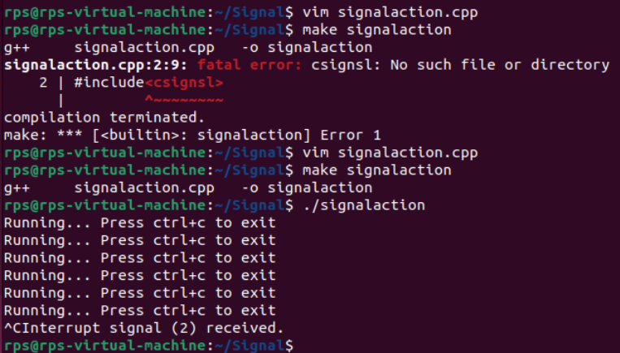

TASK 6:

SIGNAL RAISE

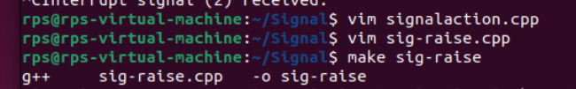

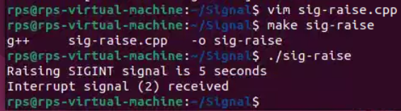

**Basic Handling vs. Advanced Control:**

**Implement signal handling using both signal and sigaction (in separate program runs). Observe the behavior. Which API allows for more control over the signal handler? Explain the key difference in a comment within your code.**

**SIMPLE Signal**

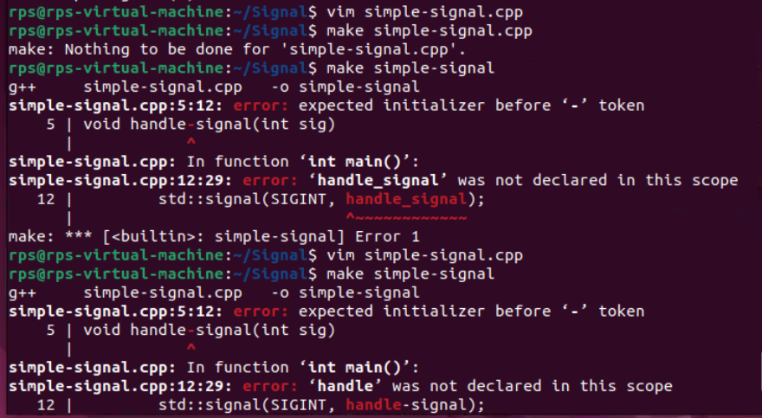

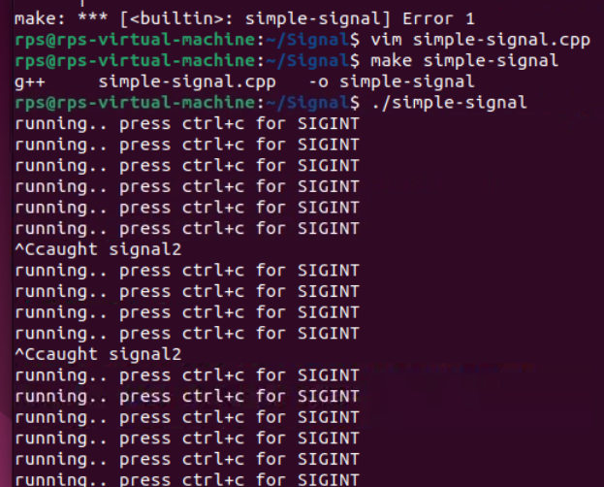

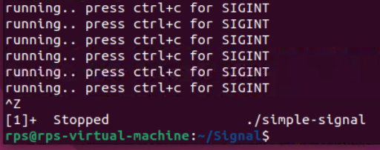

**ADVANCED SIGNAL**

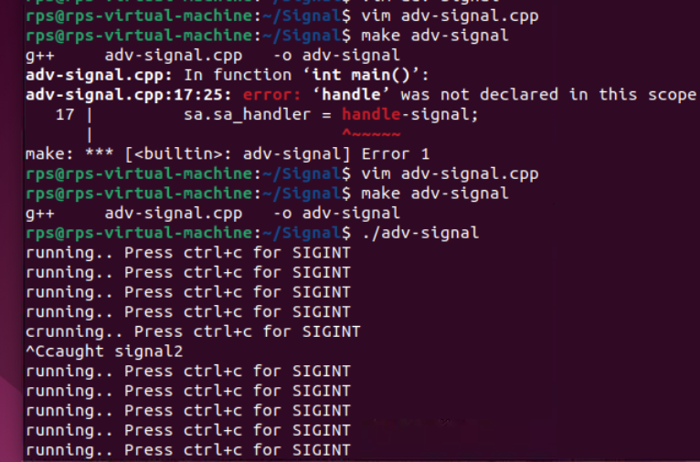

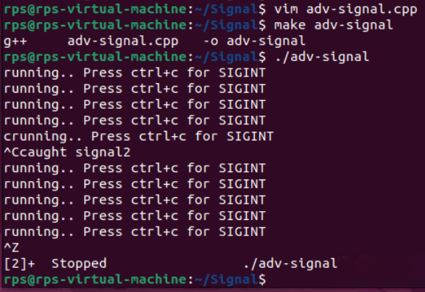

In the **sigaction**, we use **sigfillset(&sa.sa_mask)** to block all signals while the signal handler is running, providing more control over signal handling compared to the simpler **signal** function.

**Graceful Termination with Signal Handling**

**Objective: Modify your program to demonstrate graceful termination upon receiving a specific signal (e.g., SIGINT). Within the signal handler, perform any necessary cleanup tasks (e.g., closing files, releasing resources) before exiting the program gracefully.**

**Implementation:**

**In your signal handler function, include code to perform cleanup actions. This might involve closing open files, releasing memory, or writing data to disk.**

**Use exit(0) or similar methods to terminate the program after cleanup is complete.**

**SIMPLE TERMINATION**

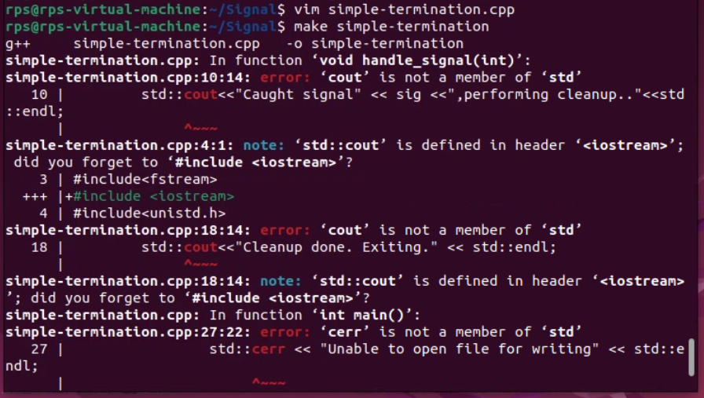

**WITH SIG-ACTION-TERMINATION**

